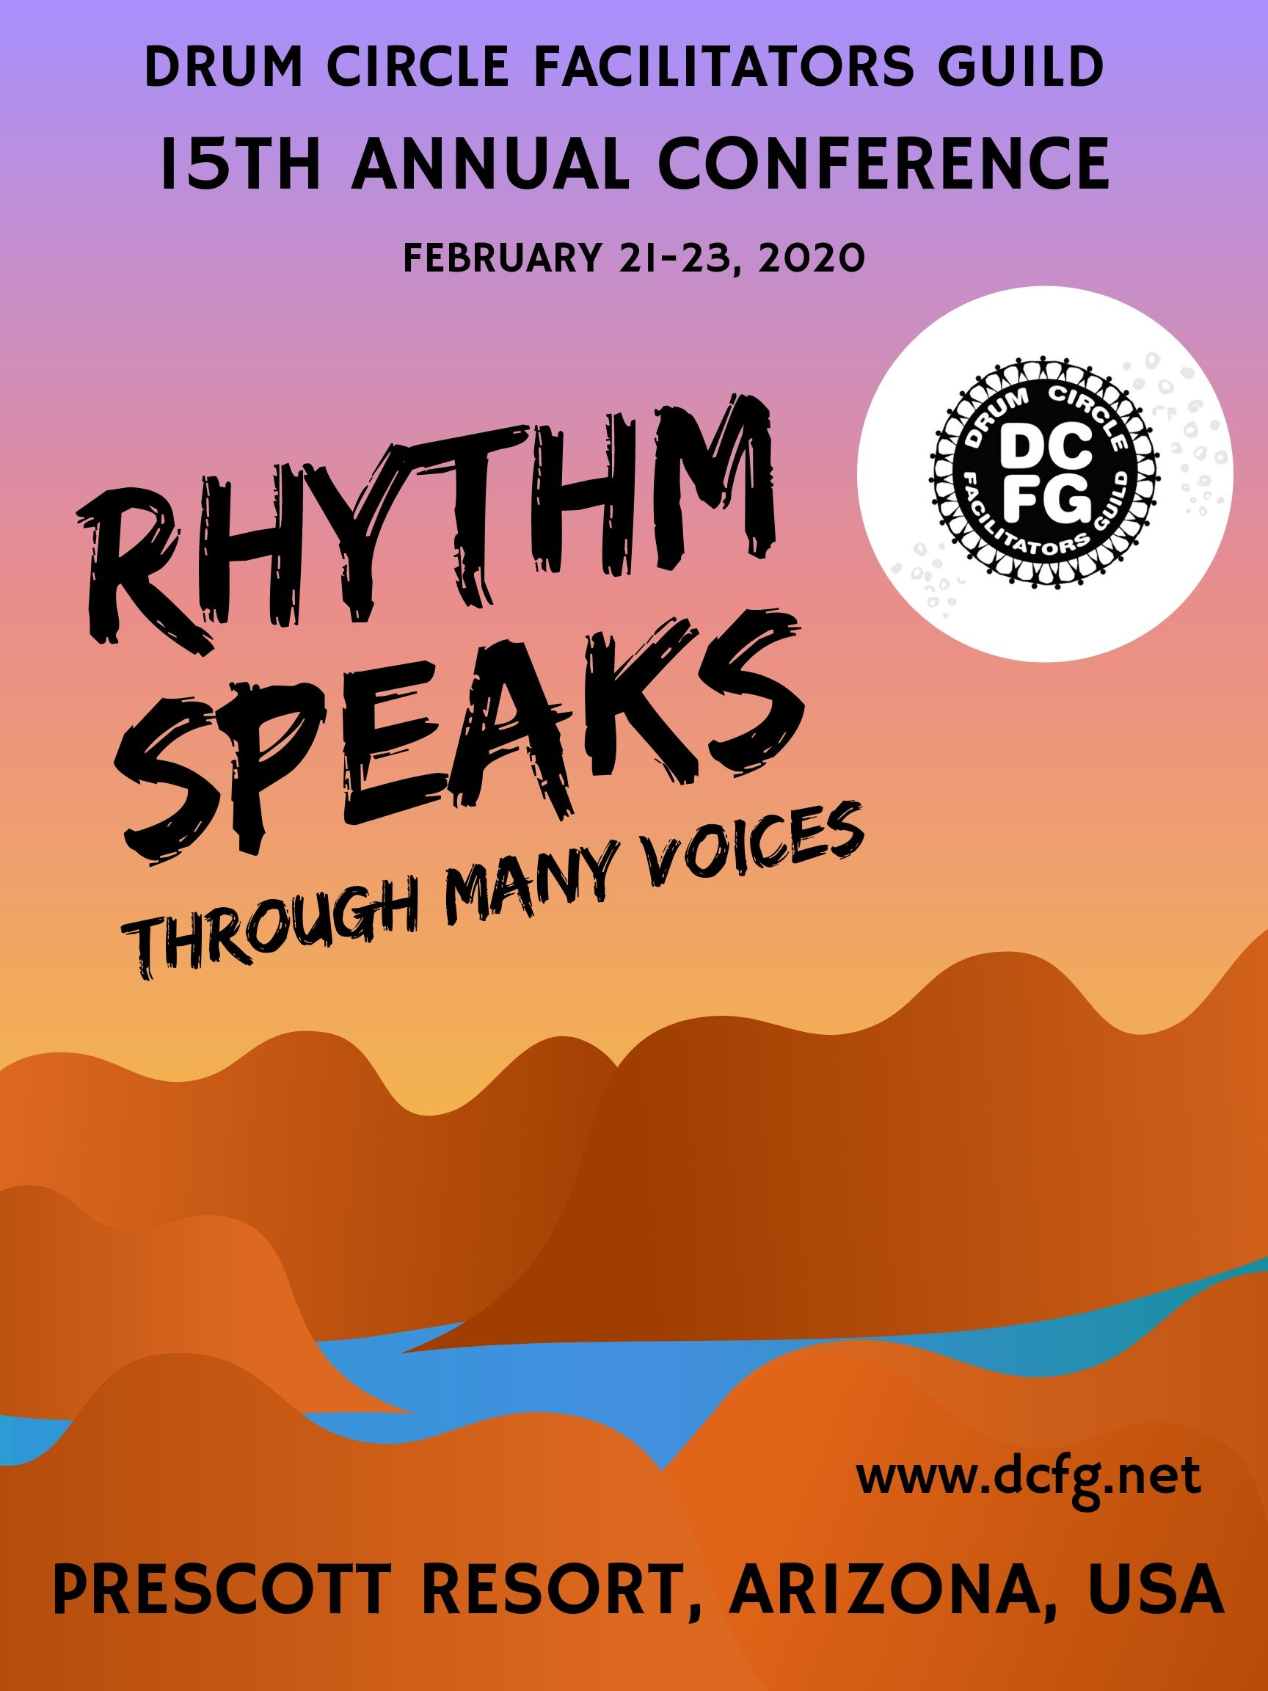

DRUM CIRCLE FACILITATORS CONFERENCE
FEBRUARY 21-23, 2020
Prescott Resort
Prescott, Arizona

Vending Space Request Form

Business Name: | Business Phone:
Contact Name: | Cell Phone:
Address:
Email address: | Website:
Full table ($40) | ______
Description of items to be sold or displayed (attach new sheet if necessary):

I need access to an electric outlet: Yes No

____ I have read and agree to the Conference’s “Detailed Vendor Information” document.

Conference vending fee: $40

Vending space reservations will be first come, first served, based on the date of the receipt of your check. If we are unable to accommodate your request for vending space for any reason, your check will be voided and returned.

Please make checks payable to DCFG, and mail your completed request form, check or money order (do not send cash) to:

DCFG Conference Vending/Exhibit Space
PO Box 222
Fulton, MD 20759
Email: wholeliferhythm@gmail.com

