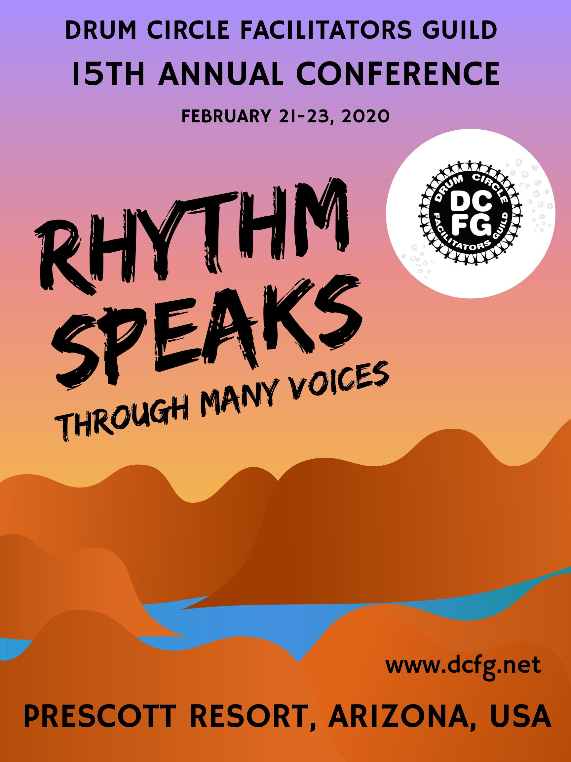
DRUM CIRCLE FACILITATORS CONFERENCE
FEBRUARY 21-23, 2020
Prescott Resort
Prescott, Arizona
— DETAILED VENDOR INFORMATION —

Dates & Times: Conference begins with registration at noon on Friday, February 21, 2020 and extends through 4 pm Sunday, February 23, 2020. There will be open vending times built into the schedule where there are no other sessions planned.
Internet: There will be free wireless internet access in the vending areas.
Space: Percussion product vendors will be provided with an exhibit space approximately 8 feet in length by 5 feet in depth, and one 2-1/2’ x 6’ table with a table cover and skirt around the perimeter of the main conference room.
Only one space per Vendor will be allowed. Space will be assigned on a first-come first-served basis.
Setup: Set up will be between 11 am and 5 pm Friday, February 21, 2020. Tear down must be completed by 8 pm Sunday, February 23, 2020
Shipping in: All products, literature, etc., MUST ARRIVE NO EARLIER than Thursday, February 20, 2020.
Conference contact & ship to address:
1500 East State Route 69
Prescott, AZ 86301
info@prescottresort.com
Attention Mary Hill
(928) 227-2313
Shipping Out: YOU MUST ARRANGE FOR PICK UP on Monday, February 24, 2020 during regular business hours. Prescott Resort has regular UPS and Fed Ex pick-ups twice daily.
Vendor fee: Payment methods. Checks and money orders for vending spaces should be made payable to DCFG and mailed to the address on the Vending Space Request Form. The fee is $40 per table. No refunds will be processed.
Conference & lodging fee: Vendor fee DOES NOT include conference registration. If you would like to attend the conference sessions, you must register and pay the full conference fee (meals are included). If you are NOT interested in attending the conference sessions, we will work with you to receive a discount on the registration fee. This will entitle you to partake of all meals and refreshments during the conference. In either case you must book you own lodging separately. See www.dcfg.net for full information.
Space Reservations: Send the Vendor Space Request Form to Michael Dermody at wholeliferhythm@gmail.com
Deadline: All requests must be received by Monday January 27th, 2020.

The Fine Print: Some adjustments to vending area may take place at the beginning of the conference. All items sold are restricted to those listed on the reservation form. The conference committee reserves the right to remove from the show items that misrepresent a vendor’s described products. The DCF Conference and its organizers are not liable for, and assume no responsibility for, vendors and participants’ equipment, inventory, employees, or agents, or for the loss or damages by fire, water, theft, natural disaster, or any other source whatsoever. Filing and payment of taxes are the responsibility of the conference participants

Contact:Please contact Michael Dermody, Vending Coordinator, with any questions. wholeliferhythms@gmail.com

