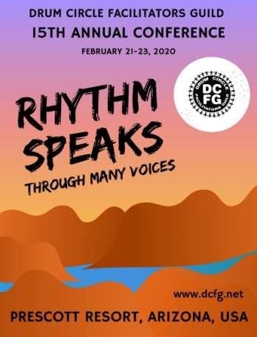
“Rhythm Speaks: Through Many Voices”
15th Annual Drum Circle Facilitators Guild Conference
February 21-23, 2020 Prescott, Arizona

Workshop Session Proposal

Applications due to Ashley Tisdale (atisdale911@gmail.com) by Monday,December 9th, 2019

Presenter Name:
Session Title:

Email: |  | Company Name:
Address: |  | Website:
City, State, Zip: |  | Phone:

- Session Description (100 words or less, EXACTLY as you want it printed in the Handbook.)

- The DCFG Conference theme is “Rhythm Speaks Through Many Voices”. How does your session compliment this theme?

- Presenter Bio / Introduction (150 words or less, EXACTLY as you want it printed in the Handbook.)

- Preferred Session Length: _____ 45 min. ____ 60 min. ____ 75 min. ____ 20 min. mini-session

Estimated Set up time needed immediately prior to session: ______ minutes

- Category: Please indicate which conference topic category best describes your session:

 | A | DCF Business Development(market presence, client base, equipment & logistics, start-up funding, etc.)
 | B | Program Design & Activities for Specific Populations (children, special needs, organizational training, health, folkloric drumming etc.)
 | C | DCF Techniques and Strategies (activities, games, resources, songs, chants, etc)
 | D | DCF Mastery (personal presence, inner development, facilitating overall event flow & energy, inter-disciplinary resources, peer feedback)
 | E | Other (Please Describe)

- Presentation modes: A participatory/interactive format is highly encouraged. What instructional modes do you plan? (check all that apply)

 | Drums only |  | Percussion only |  | Drums & Percussion
 | Body Percussion |  | Singing / Vocals |  | Movement
 | Large group talk/presentation |  | Breakout discussion groups |  | Other:

- Outcomes: What knowledge or skills will conference attendees gain from your session to apply to their DCF practice?

- Room Format: What configuration of chairs do you need?

 | Seminar (U-shape with front presentation area) -- WITH projection screen |  | Seminar (U-shape with front presentation area) -- NO projection screen |  | Drums / Percussion  circle |  | Wide circle with room for movement in middle

Do you have any other room setup requirements?

- Audio-visual requirements
Please circle:

Wireless Mic LCD Projector & Projector Screen Flip Chart

Other: ___________________________________

- Additional materials
Participant handouts are strongly encouraged; they will be included in the Virtual Conference Handbook.
Please check one:
Yes, I will provide a handout file for inclusion in the Handbook by January 10, 2020
I will bring copies of handouts myself
No, handouts will not be used for this session, because (please give reason):

- Instruments and materials required:
Instruments provided by you
Instruments provided by participants
Other play objects (provided by?)
Paper, pens, art supplies, etc. (provided by?)

- Other requirements or special requests
Do you have any additional requirements or special requests? (Y/N) If yes, please describe:

M: Please initial
_______ I understand that DCFG will attempt to meet the needs of all presenters, but cannot guarantee that DCFG will be able to accommodate every request.

_______ Presenters will be responsible for registering for the conference. Presenters will receive a registration discount of 50% off of the normal registration rate of $375, therefore will be paying $187.50 for conference registration.
As discussed, we have requested a waiver on this in return for providing the two presentations under discussion.
_______ I give DCFG permission to take photos and video of my session, and to use photos/video on the DCFG website or video channel.

Please email completed form (as attachment) and/or questions to atisdale911@gmail.com

